**Consumption of Natural Gas in the Fertilizer Industry**

Introduction:

The ammonia and urea industries represent significant and vital components of the chemical economy. They serve as important sources of revenues and employment, within countries with large availability of feed stocks such as natural gas and coal.

India’s gas industry is in a state of transition. The country faces a broadening gap between indigenous supply and demand. The initiative for exploiting the commercial potential of natural gas as feedstock and fuel by planning NGFF for producing urea fertilizer in the mid-1950s was based on a single gas field in what is now Bangladesh. The use of natural gas as a fuel in Chhatak Cement Factory in 1960 replaced imported coal and thus began the era of cleaner fuel for industries in Bangladesh. It is only from 1984 that the power sector's natural gas consumption exceeded that of the fertilizer sector. Urea fertilizer together with natural gas-based electricity is today recognized as the cornerstone of the country's food security and political stability.

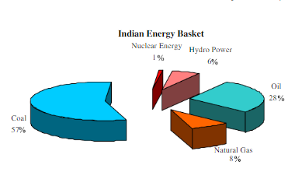 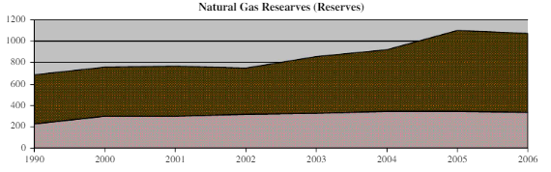

Modularity:

For the Consumption of Natural Gas in Fertilizer Industry, there are different modules to look upon while collected and distributing the data:

* **Interface Creation:** The main interface should be created externally for displaying and viewing the dataset and for feedback purposes on how reducing the impact of high amount of natural gas usage.
* **Count of Industries:** The total count of number of industries and the percentage of natural gases used in different number of cities across India.
* **Yearly Report:** The natural gases used in different cities with different amount will be clubbed together and shown in a yearly report with percentage of increment or decrement.
* **Other Type of Gases:** Not only the natural gas would be taken into but also the different kind of gases used in the fertilizer industry.
* **Uses of Natural Gas:** The usage of the natural gas in different products of the fertilizer industry would be collected and a report of what impact it causes, show in the growth rate of the industry.
* **Report Generation:** The data collected from various sources would be put down as a whole single report and details about the amount and consumption of natural gas in different places will be shown.

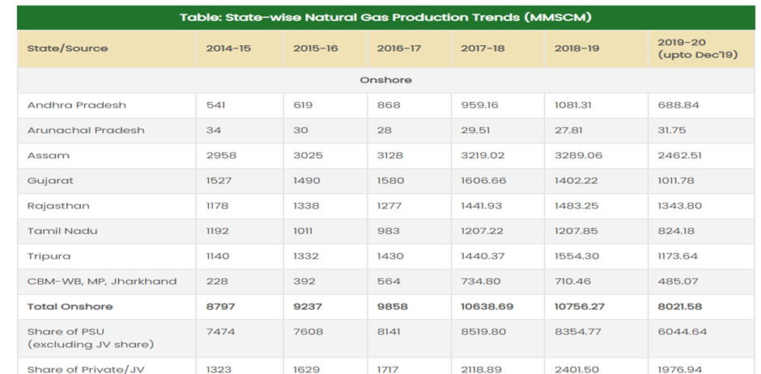

Functionalities of the system:

* In a fertilizer industry, there are a lot of processes which include production of main fertilizer products i.e., UAN (Urea Ammonium nitrate), Single superphosphate (SSP), Triple superphosphate (TSP), Muriate of potash (MOP), Potassium nitrate (KN) etc…
* The industry contains Primary reformer (PRF), Auxiliary boilers (utility boilers) to burn natural gas.
* There is an overview of the resources which will be displayed in the webpage.
* It includes the consumption of natural gas in different fertilizer industries and the amount of natural gas which is consumed to convert into a fuel.
* The screens show the data which consists of the name of the industries, the year in which they started to consume and the amount of consumption.
* Not only natural gas, even other types of gases such as nitrogen, phosphorus, potassium are used as intermediate products to make mineral fertilizers.
* Furthermore, a graph which represents the trade balance of the natural gas will be displayed.
* Finally, an entire report containing the following sources will be projected for information purpose.
* The following data which will be displayed is already stored in the database.

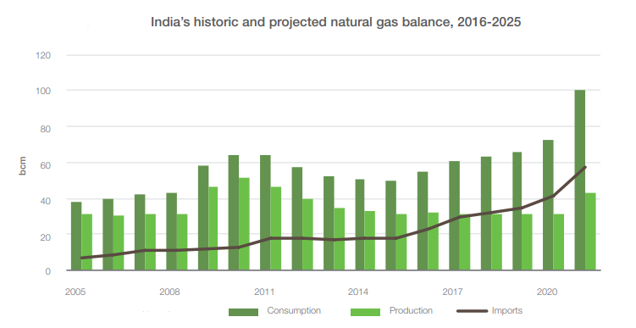

**Benefits of the system**

This system supports and generates reports about the natural gas database, representing them in a statistical way to show the liters of gases consumed, exported, imported and used within our country using MongoDB and UI website.

**ER Diagram**

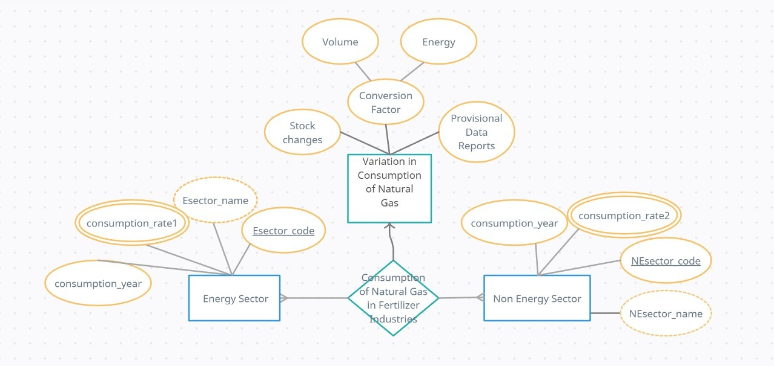

**Name of the Team: Javaders**

|  |  |  |  |
| --- | --- | --- | --- |
| **Sno** | **Roll No** | **Name** | **Role**  **(Project leader, Designer, Developer, Test & Document)** |
| 1 | CSE21257 | Shreenithi.S | Leader |
| 2 | CSE21220 | Naveen Raagavendran | Designer |
| 3 | CSE21207 | Ashiq Sheriff | Developer |
| 4 | CSE21238 | Mathamgi Nair | Testing and Documenting |

**Development Platform:**

* For Database - MongoDB
* For User Interface - Java